MINI ANALOG PIANO
PROJECT REPORT

INTRODUCTION
This project aims to design a Mini Piano circuit using a 555 timer IC, momentary push-button switches, resistors, capacitors, and a speaker. The electronic piano produces different tones corresponding to different keys, effectively mimicking a real piano's basic functionality using simple electronic components.

COMPONENTS REQUIRED

Component | Quantity | Type/Value | Notes
Integrated Circuit  (IC) | 1 | NE555 Timer IC | Core timing component.
Resistor | 10 | 1k | Resistor to set Frequency
Resistor | 1 | 4.7k | Resistor to set frequency
Capacitor | 1 | 100nF | Capacitor
Capacitor | 1 | 10uF | Electrolytic or Tantalum capacitor (usually polarized).
Buzzer/Speaker | 1 | 12V | Used for audio output.
Push Button | 7 | - | Momentary switches.
PCB/Prototyping  Board | 1 | Zero PCB | General-purpose perforated board.
IC Socket/Base | 1 | - | To easily insert and remove the IC without soldering directly.
Soldering Material | As Needed | - | Solder wire, flux, etc.

WORKING PRINCIPLE & CIRCUIT DIAGRAM
The core of the mini piano circuit is the 555 timer IC configured in astable mode, which generates a continuous square-wave signal. Each push-button switch is coupled to the circuit with a unique resistor. When a button is pressed, it changes the resistance in the timing circuit, thus changing the frequency of oscillation of the 555 timer. The output frequency determines the sound's pitch from the speaker.
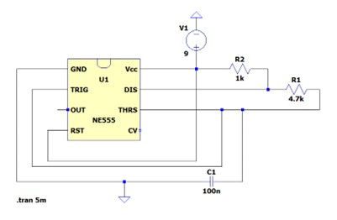
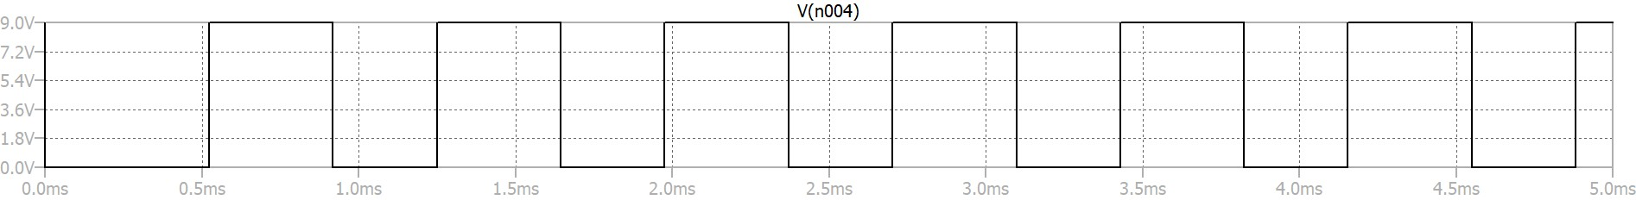

Procedure :

1. Project Inception and Planning
The project idea was formally determined and agreed upon through collaborative discussion and consensus among all team members.

2. Circuit Design and Simulation
The electronic circuit schematic was designed and verified using the online circuit simulation software, LTSpice. This step ensured the theoretical functionality and expected performance of the design prior to physical implementation.

3. Component Procurement
All electronic and mechanical components required for the successful construction of the circuit, as detailed in the Bill of Materials, were purchased and prepared for assembly.

4. Prototyping on Breadboard
The initial circuit was implemented and tested on a solderless breadboard. This stage served as a functional prototype to confirm connectivity, test component values, and ensure the circuit's operation met the design specifications.

5. Final Fabrication
Following successful validation on the breadboard, the components were permanently fabricated and soldered onto a Zero Printed Circuit Board (PCB). This resulted in the final, robust physical realization of the project.

OBSERVATIONS
- The pitch of the sound changes with each key, confirming frequency variation due to different resistor values.
- Stable and clear audio output can be achieved by selecting suitable resistor-capacitor pairs.
- The circuit is robust and works reliably on a breadboard for demonstration purposes.

CONCLUSION
The mini piano project effectively demonstrates how one can use a 555 timer in astable mode to generate different sound frequencies by modulating resistance. By pressing different push-buttons, users control the frequency of the signal delivered to the speaker, hence simulating piano notes. The project offers insights into both practical electronics and the fundamentals of musical tone production using simple components.

LEARNINGS:
- Ability to Design Circuits: Successfully learned the methodology for designing electronic circuits suitable for various practical applications.
- Skill in Component Selection: Developed the competence to select and specify optimal components based on circuit requirements and performance criteria.
- Proficiency in Assembly: Acquired the necessary soldering and assembly skills for the professional fabrication of electronic circuits.
PROJECT IMAGES

